COMP 4260 Game Mechanics Analysis

Spring 2013

Prof. Stucki

**Stephen, Brad, Richard**

Based on Chapter 10: *Some Elements are Game Mechanics*, think about each of the following aspects of game mechanics and answer the questions as they relate to your team’s game.

1. **Space:**
2. **Answer each of the questions in Lens #21.**
   1. Our space is continuous
   2. Our game has two dimensions
   3. The space is divided into two spaces: the field and the wall
   4. There are no subspaces
   5. Theoretically there are different ways to model the space of the game
3. **Are there any ways in which your game’s use of space is innovative? Explain.**
   1. We have buttons for upgrading. Part of the edge of the screen is used for upgrading the railgun and the wall’s defense. But this has more to do with the controls rather than the space. Other than that, our space isn’t all that innovative
4. **Objects, Attributes, & Space:**
5. **Answer each of the questions in Lens #22.**
   1. Objects: dragons, railguns, wall
   2. Attributes: hp, position, speed, damage
   3. States: dragons have different states
   4. Attributes known by:
      1. only the game: attribute scaling variables not known
      2. all players: player name, player score
      3. one player: current state of the game, upgrades, etc.
6. **.On a separate sheet of paper, draw the state diagrams for any objects that will have complex behavior in your game.**

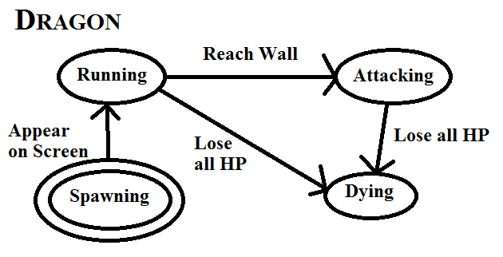

1. **Actions: Describe the operative actions that will be available to players in your game. How do you anticipate these operations influencing the player’s experience (refer to Lenses #23 & #24 for ideas).**

* Moving
* Firing
* spending upgrades
* entering in the highscores
* setting sound on/off

1. **Rules:**
2. **What is the goal of your game? What is the player’s objective?**
   1. Defeat the dragons
   2. Reach a high score
3. **How will a player learn how to play your game?**
   1. Info page
   2. Trial and error
   3. Visual cues
4. **On a separate sheet of paper, write down all the rules of game play (i.e. *Operational Rules*), including information about scoring and/or winning the game.**
   1. The player can move along the wall
   2. The player can shoot at the dragons
   3. The player can upgrade the weapons when they have enough gold
   4. The player will receive a certain amount of gold and points for killing each dragon
   5. The game ends when the dragons knock down the wall
5. **Skill:**
6. **Make a list of skills required in your game and categorize them both as physical, mental, or social and as real or virtual.**
   1. Managing upgrades
   2. Mental acuity
   3. Being able to hold a device
   4. Touch the screen
   5. Ability to have friendly competition with other people
   6. Using a railgun
   7. Aiming
   8. Hand-eye coordination
7. **Look at the questions in Lens #27 and comment on those you think are relevant to your game.**
   1. Lacking skills: Social skills
   2. Dominant skills:
      1. Mental:
         1. Decision making
      2. Physical:
         1. Hand-eye coordination
   3. Some players are better at this than others
      1. It does not make the game unfair
   4. Players can improve their skill with practice
   5. This game demands the right level of decision making, but not too much of hand-eye coordination
8. **Chance: Discuss how chance or randomness is incorporated into your game. What are the expected values of the various chance events? How are these impacting the player experience?**

The dragons randomly spawn on the board. The positions of the dragons randomly spawning on the board is rather hard to quantify. I guess we could quantify the expected value of the y coordinate, which is expected to range anywhere from the top of the canvas to the bottom.

It makes the game different each time the player plays.